Advanced Practical Computer Concepts

Final Project Proposal

Gregory Sprenger

BLAST is an alignment search tool that can compare a query sequence to another sequence or a database to identify similarities. This allows for inferences, such as relationships and functionality, to be made between the sequences. For each alignment that is found between the query and subject sequence, the statistical significance score is calculated based on several factors such as how many amino acids between the two sequences match and if there are any gaps in between the matched areas. It also identifies the start and end of the matches of both the query and subject sequence.

The objective of this project will be to recreate a simple web-based BLAST tool to identify similarities between two sequences. This will be done with an index HTML file that contains two forms that allows one FASTA sequence in each form. Once submitted, the sequences will be passed to the BLAST tool on the server side to identify similarities between the sequences. Once completed, a python CGI script will be used to parse the information from the results and display them in the browser. Also, an “add to database” checkbox and a drop-down menu will be added to the index HTML file. Therefore, if the checkbox is selected, after the analysis is completed the results will be appended to a MySQL database and the data will be able to be retrieved if selected in the drop-down menu that will be populated via JQuery. This will alleviate re-running the same query and subject comparison.

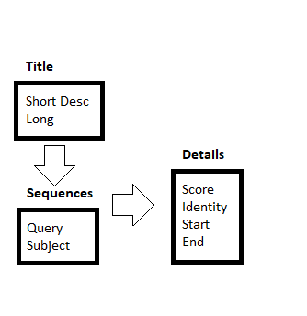Here are tentative examples of the index HTML file and MySQL database:

Index.html Example:

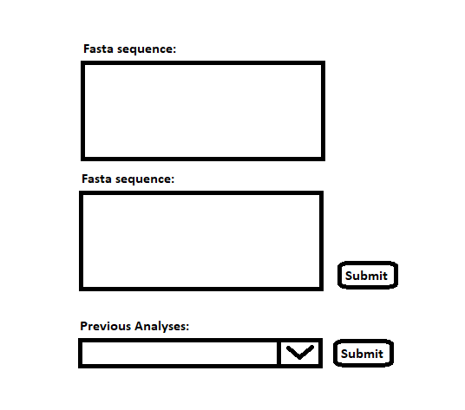

MySQL Database Example: